J&K Grameen Bank *Head Office, Narwal Ph: 9797127377 E:pdg.hoj@jkgb.in*

*Near Fruit Complex, Jammu. W: www.jkgb.in*

*180006*  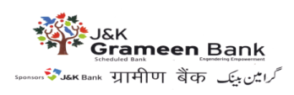

***GENERAL* ADMINISTRATIVE *DEPARTMENT***

**Ref. No: - JKGB/GAD/ 2025-26/ 136**  **Dated: 09-04-2025**

**TENDER NOTICE**

J&K Grameen Bank hereby invites tenders regarding rate contract for AMC of Servo-Stabilizers for Branches / Offices of the Bank located in UT of J&K and UT of Ladakh for a period of 02 years. The tender documents can be downloaded from the Bank’s website [www.jkgb.in](http://www.jkgb.in) from 09-04-2025 to 02-05-2025. For more information, visit www.jkgb.in

**Sd/-**

**HOD**

**GENERAL ADMINISTRATIVE DEPARTMENT**