**J&K Grameen Bank *Head Office E:personnel.hoj@jkgb.in***

***Narwal - 180006***

***Jammu – J&K***

***DP&TB cell, HRDD.***

***Ref No : JKGB/HO/DP&TB/2024-25-4249***

***04th of October 2024.***

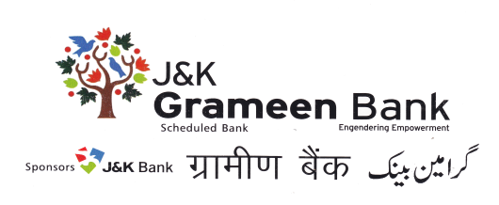

**PUBLIC NOTICE**

**Regarding implementation of Pension Scheme in Regional Rural Banks (RRBs) w.e.f 01.11.1993.**

Department of Financial Services, Ministry of Finance, GOI, vide its letter no 8/4/2024-RRB dated 03.10.2024 on the captioned subject has conveyed that under the directions of the Hon’ble Supreme Court, Government has decided to implement the pension scheme in Regional Rural Banks with effect from 01.11.1993 (currently under implementation w.e.f. 01.04.2018), along with payment of consequential arrears to the eligible pensioners/family pensioners.

As such, all those employees who were in service of the Bank on or before 31.03.2010 will be eligible for the benefit of pension from 01.11.1993 of from date of cessation of service.

Therefore, **through this public notice**, it is informed to all such eligible officers / employees who were in the service of Bank between 01.09.1987 and 31.03.2010 and

* Are currently not drawing pension from the bank;
* Who have been removed/dismissed/terminated (including CRS) from service of the Bank;
* Who have resigned from services of bank by giving proper notice but have rendered minimum 20 years of service;
* Who have opted for Voluntary retirement due to medical incapacitation and are not drawing pension;
* The legal heir of deceased pensioner who died before 31.10.1993.
* The legal heir/s who have lost both pensioner /family pensioner after 01.11.1993;

to apply for the benefit of pension along with necessary documents (to be downloaded from Banks website (www.jkgb.in) and forward the same to DP&TB Cell, HRDD through any branch of J&K Grameen Bank where from he/she is willing to draw pension.

The last date for submission of application is **09-10-2024.**

Please note that eligible officers /employees (legal heirs in case of deceased eligible officers / employees) who are currently drawing pension (or family pension) need not to apply for payment of consequential arrears separately.

In case of any query, please feel free to contact DP&TB Cell, HRDD at 8082187899.

**By Order**

Sd/-

HOD, HRDD.