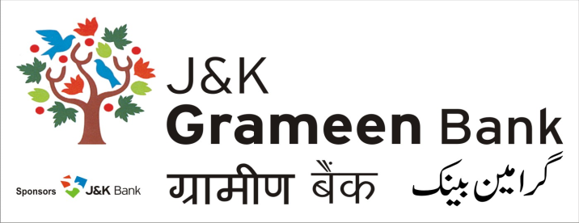**General Administrative Deptt. (GAD)**

**HEAD OFFICE**

**NARWAL, JAMMU**

**Mobile No.: 9797127377**

**E-mail:** [pdg.hoj@jkgb.in](mailto:jkgbpdg@gmail.com)

**Website:** [www.jkgb.in](http://www.jkgb.in/)

--------------------------------------------------------------------------------------------------------------------------

**Ref.No: JKGB/GAD/2024-25/6290 Date: 24.12.2024**

**Rate Contract for supply and installation of UPS/Batteries - Extension Notice**

This is in reference to tender document having Ref No. JKGB/GAD/2024-25/5274 dated 14-12-2024 regarding *Rate contract for supply and installation of UPS/Batteries.* In this regard, it is informed that the last date of submission of tender has been extended to 30**.12.2024 upto 5:00 P.M**. The technical bids shall now be opened on 31**.12.2024 at 12:00 Noon at J&K Grameen Bank, Head Office Narwal Jammu.**

All other Terms & conditions shall remain the same.

**Sd/-**

**HOD**

**General Administrative Deptt. (GAD)**